OSU Middle School Concert Band Academy
Pick-up Locations
3
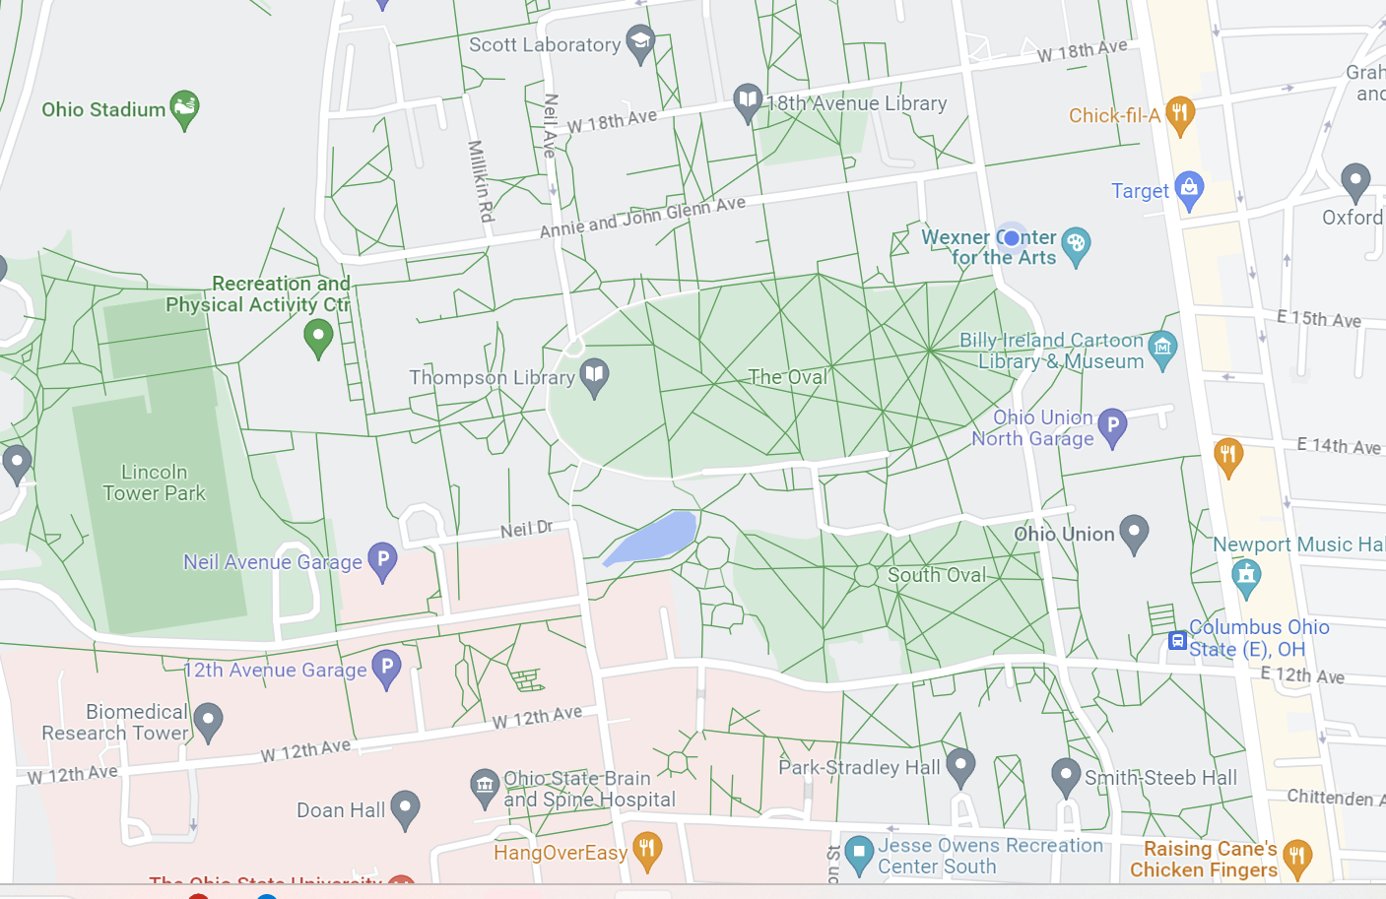
Timashev Family Music Building (Where camp is)
1
2

1. If your student plays trumpet or trombone, please pick them up at the Jesse Owens South (JOS) Recreation Center Parking Lot (11th and Highland).
2
2. If your student plays flute, oboe, clarinet, bassoon, French horn, euphonium, or tuba, please pick them up at Union South Loop driveway (located on W. 12th Ave). This is the same as the morning drop-off location.
3. If your student plays saxophone (alto, tenor, or bari) or percussion, please pick them up at the Ohio Stadium Northeast parking lot (411 Woody Hayes Dr, Columbus, OH 43210).

